**3.1 Ultrasonic Sensor**

**Tester’s names:** *Tianyi Zou* **Test Date:** *03/15/18* **Software Version:** No code is used in this test.

**Hardware Version:** This test does not need a robot built. Only the brick and sensors are used.

**Objective:**

Determine the accuracy of ultrasonic sensors by testing which ultrasonic sensor has a least amount of error in the distance it measures.

**Procedure:**

1. Turn on the EV3 brick. Connect the Port 1 of the brick to the light sensor via a cable.
2. Assemble the ultrasonic sensor vertically in front of the robot. Make sure that the sensor should direct to the front of robot.
3. Use the tools application on the EV3 brick. Select **Tools>Test Sensors >Go> Port 1>EV3 Ultrasonic >Distance**.
4. Record the real distance from each tile and the measured value on the screen of brick. Please refer to the Figure 3.1.1.

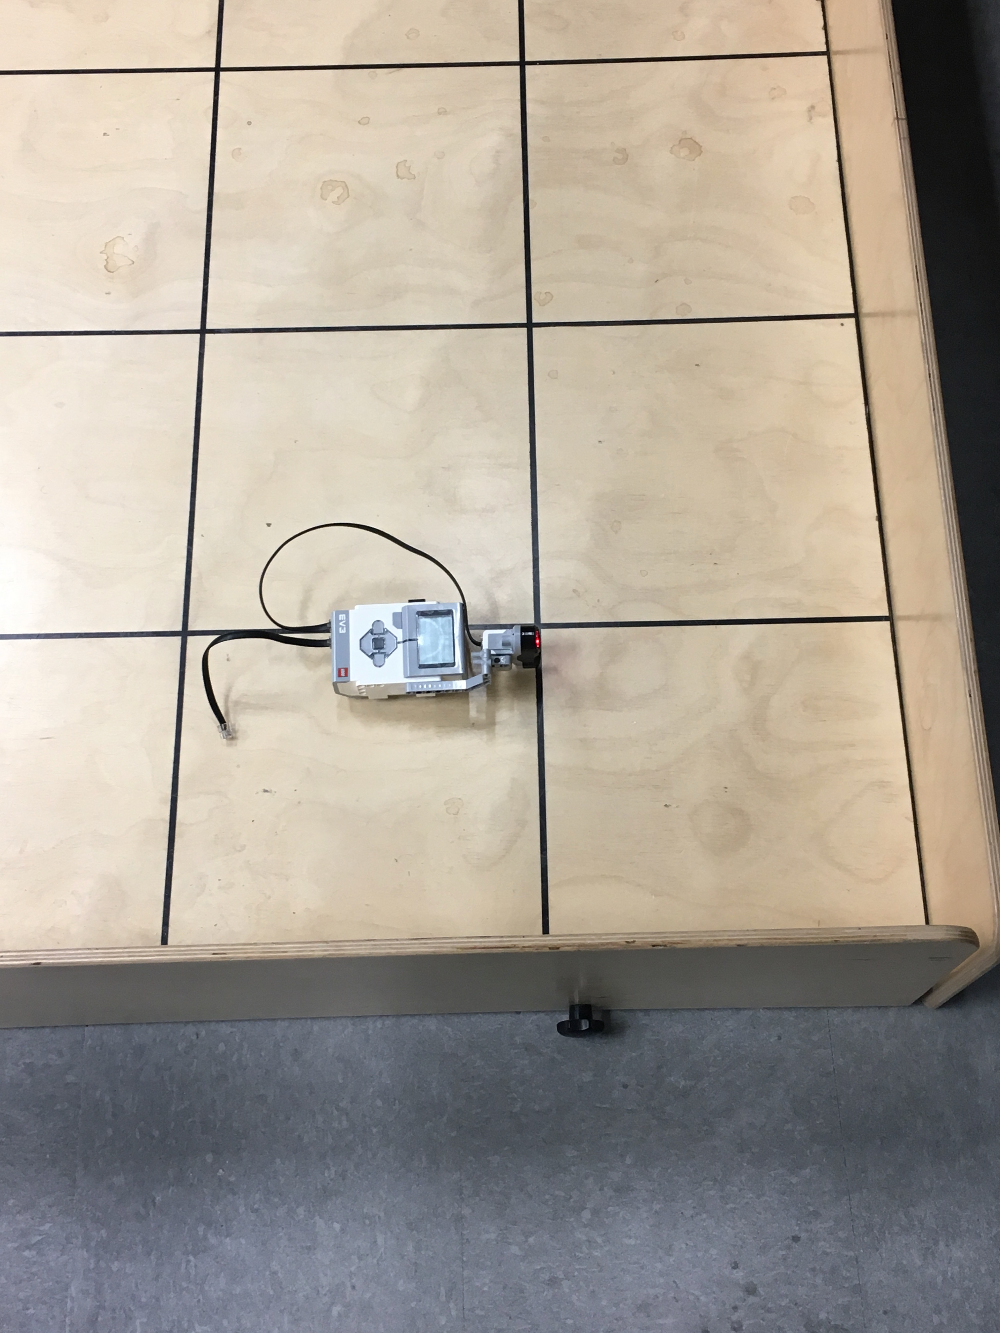

Figure 3.1.1 Placement of ultrasonic sensor during the test

5. Calculate the average value and standard deviation of error that between real distance and measured distance.

6. Test other two ultrasonic sensors by using the same procedure. Compare the result from all different ultrasonic sensors.

**Expected result:**

We expect all the sensors would provide small inconsistencies when measuring distances and different ultrasonic sensor would perform differently. Some sensor would perform better than others, which give us a sense which sensor to choose for object avoidance and localization.

**Test Report**:

|  |  |  |  |  |  |  |
| --- | --- | --- | --- | --- | --- | --- |
|  | **US Sensor 1** | | **US Sensor 2** | | **US Sensor 3** | |
| **Real distance (cm)** | **Measured distance (cm)** | **Error (cm)** | **Measured distance**  **(cm)** | **Error (cm)** | **Measured distance**  **(cm)** | **Error (cm)** |
| 29.8 | 30.4 | 0.6 | 30.4 | 0.6 | 30.2 | 0.4 |
| 60.1 | 62.2 | 2.1 | 67.0 | 6.9 | 64.3 | 4.2 |
| 90.4 | 91.6 | 1.2 | 91.7 | 1.3 | 91.7 | 1.3 |
| 120.7 | 121.8 | 1.1 | 122.3 | 1.6 | 121.7 | 1.0 |
| 151.3 | 152.9 | 1.6 | 152.9 | 1.6 | 152.1 | 0.8 |
| 181.6 | 182.9 | 1.3 | 182.9 | 1.3 | 182.4 | 0.8 |
| 211.9 | 213.6 | 1.7 | 213.0 | 1.1 | 213.2 | 1.3 |

|  |  |  |  |
| --- | --- | --- | --- |
|  | **Sensor 1** | **Sensor 2** | **Sensor 3** |
| **Average Error (cm)** | 1.37 | 2.06 | 1.40 |
| **Standard Deviation (cm)** | 0.48 | 2.16 | 1.27 |

**Conclusion**:

The average error of US sensor 1 is the lowest and also it has the lowest standard deviation among three sensors. This means sensor 1 provides more accurate values in distances.

**Action**:

We use ultrasonic sensor 1 as the priority choice. If more than one ultrasonic sensor needs to be used, sensor 3 would be the second best choice.

**Distribution**: Hardware team

# 3.2 Light Sensor

**Tester’s names:** *Enan Zaman, Tianyi Zou* **Test Date:** *03/12/18* **Software Version:** No code is used in this test.

**Hardware Version:** This test does not need a robot built. Only the brick and sensors are used.

**Objective:**

Determine which light sensor performs best by testing the distance between sensor and object where the sensor is able to detect object.

**Procedure:**

1. Put a blue block on the table platform. Put a ruler adhere to the blue block.
2. Turn on the EV3 brick. Connect the Port 1 of the brick to the light sensor via a cable.
3. Use the tools application on the EV3 brick. Select **Tools>Test Sensors >Go> Port 1>EV3 Color >Color ID**.
4. Place the light sensor close to the ruler and adhere to the block. Make sure the direction of light should be towards to the blue block.
5. Move the light sensor away from the block slightly.
6. Record the distance (d1) between the light screen of light sensor and the block where the value of color ID shown on the screen of EV3 brick becomes from -1.0 to 3.0.
7. Repeat step 5 and record the distance (d2) between the light screen of light sensor and the block where value of color ID becomes from 3.0 to 7.0.
8. Test other two light sensors by using the same procedure.

**Expected result:**

We expect each sensor shows slightly different values in term of d1 and d2. However, generally the value should be around 1.0-1.5cm based on previous labs we have done.

**Test reports:**

|  |  |  |
| --- | --- | --- |
|  | d1 (cm) | d2 (cm) |
| Light sensor 1 | 0.2 | 1.5 |
| Light sensor 2 | 0.2 | 2.0 |
| Light sensor 3 | 0.2 | 1.8 |

**Conclusion:**

The value of d1 and d2 are respectively the closest and farthest distance that the light sensor is able to precisely detect an object, which means light sensor can both detect the object in front of it and identify the color of the object in such distance.

As we have expected, different light sensor performs differently. We will pick light sensor 2 as the priority choice for localization because it can detect object in a widest range of distance. If more than one light sensor need to be used, light sensor 3 would be the second best choice.

**Action:**

The light sensor should be placed at the range of 0.2cm-1.5cm away from the object to be detected.

**Distribution:** Hardware team